if n==0 then

y=1;

else

y=0;

end

disp(y);

plot2d3(n,y);

xlabel("time");

ylabel("amplitude");

title("Delta Function");

end

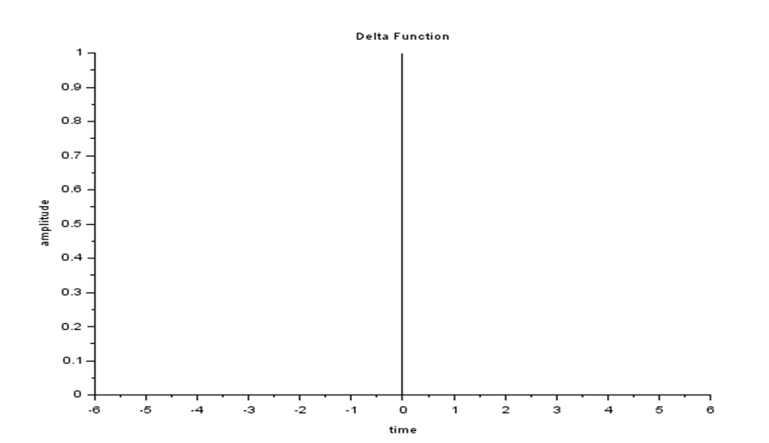

for n=0:5;

y=1;

disp(y);

plot2d3(n,y);

xlabel("time");

ylabel("amplitude");

title("Unit step Function");

end

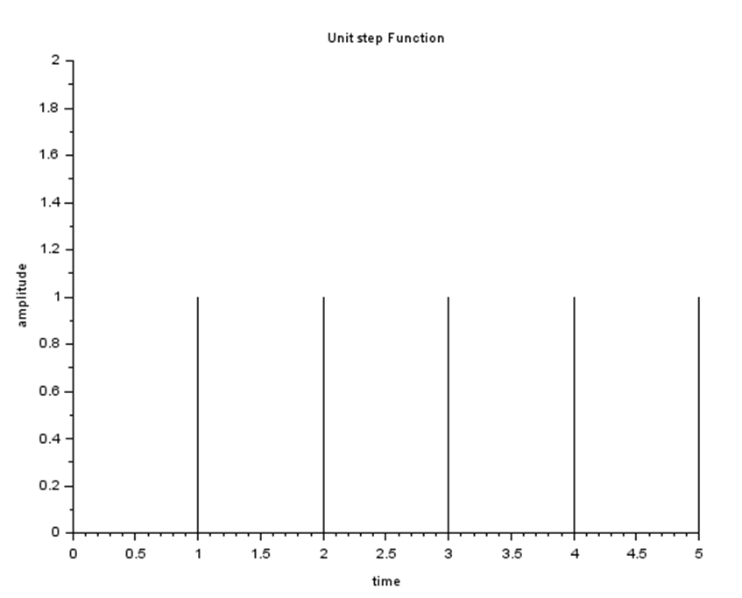

for n= 0:10;

y=n;

disp(y);

plot2d3(n,y);

xlabel("time");

ylabel("amplitude");

title("Ramp Function");

end

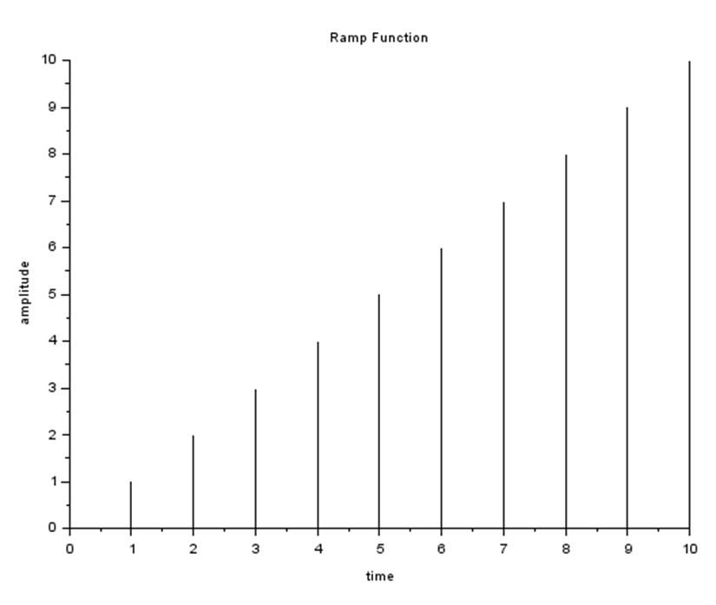

for n= -5:5;

if n>=1 then

y=1;

else

y=0;

end

t=2^n\*(y);

disp(t);

plot2d3(n,t);

xlabel("time");

ylabel("amplitude");

title("2^n\*u(n-1)");

end

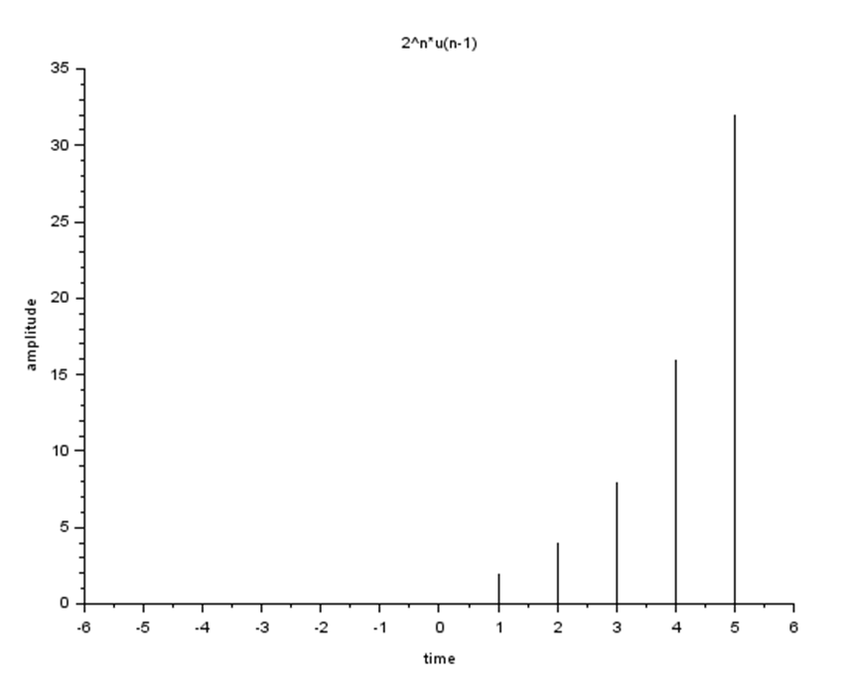

for n= -5:5;

if n>=-1 then

y=1;

else

y=0;

end

t=2^n\*(y);

disp(t);

plot2d3(n,t);

xlabel("time");

ylabel("amplitude");

title("2^n\*u(n+1)");

end

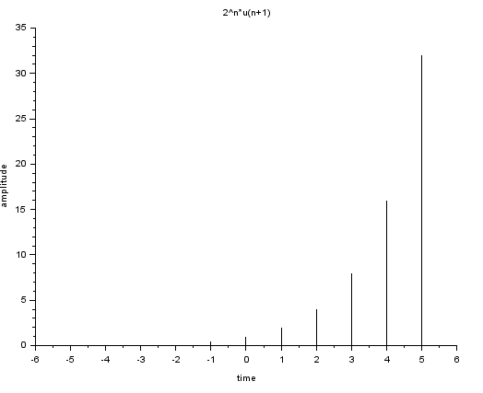

for n= -5:5;

if n<=-1 then

y=1;

else

y=0;

end

t=2^n\*(y);

disp(t);

plot2d3(n,t);

xlabel("time");

ylabel("amplitude");

title("2^n\*u(-n-1)");

end

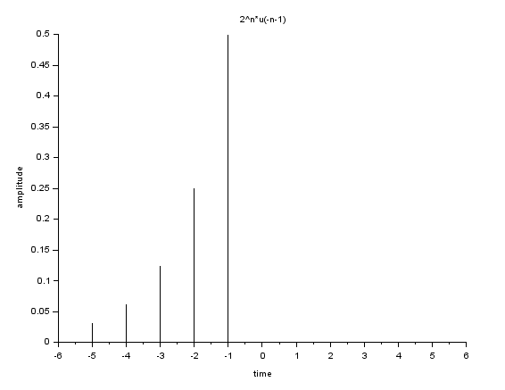

for n= -5:5;

if n<=1 then

y=1;

else

y=0;

end

t=2^n\*(y);

disp(t);

plot2d3(n,t);

xlabel("time");

ylabel("amplitude");

title("2^n\*u(-n+1)");

end

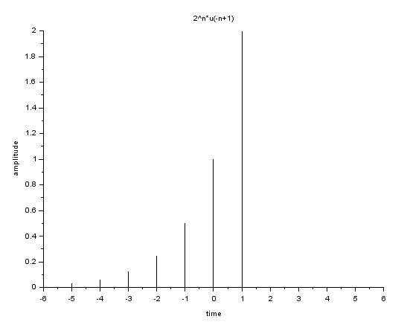

n0=1;

n1= -2;

n2= 5;

n=n1:n2;

x=[n-n0>=0];

y=(2.^n).\*(x);

disp(y);

plot2d3(n,y);

xlabel("time");

ylabel("amplitude");

title("2^n\*u(n-1)");

end

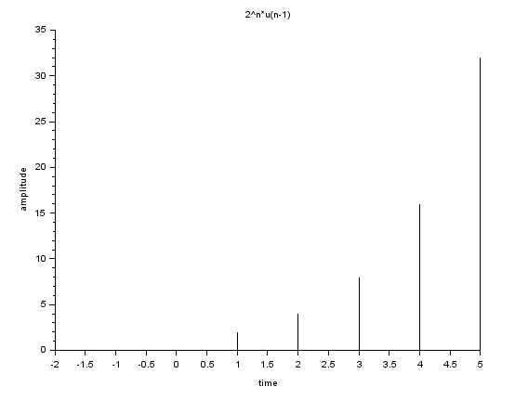

n0=-1;

n1= -2;

n2= 5;

n=n1:n2;

x=[n-n0<=0];

y=(2.^n).\*(x);

disp(y);

plot2d3(n,y);

xlabel("time");

ylabel("amplitude");

title("2^n\*u(-n-1)");

end

